- What is the relation between definite integrals and area?
- Why is the Fundamental Theorem of Calculus so important?
- Give examples on how the method of substitution works with definite integrals.
- What integrals lead to logarithms? Give some examples.

- What is the relation between definite integrals and area?
In a sense they are the same but area typically refers to the boundary which are straight lines or complete circles such as the area of a rectangle or cylinder. The definite integral is the area of a space which boundaries can be defined by a continuous function which may not have a constant behavior.
Both rectangle or cylinder boundaries have a constant behavior so the area can be calculated using a standard formula but in the real world, we rarely need to find the area to perfect shapes. Understanding how to calculate the area under a curve is a more realistic use case, thus we use the definite integral.
- Why is the Fundamental Theorem of Calculus so important?
I feel this is a fundamental theorem to calculus because Calculus is defined as “the branch of mathematics that deals with the finding and properties of derivatives and integrals of functions”. So Calculus defines itself as the tool used to definite integrals and area and other areas of math focus on other aspect of calculations.
- Give examples on how the method of substitution works with definite integrals.
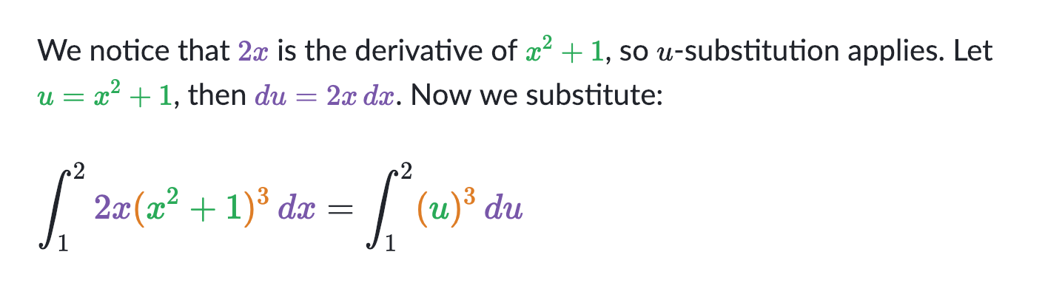
In the example we can see that with substitution we can solve this problem.
- What integrals lead to logarithms? Give some examples.
The derivative of ln x is $1/x$ and the process in reverse is the integral of $1/x$is ln x + c. From this example you can see that logarithms is the reverse of derivative. From this we can derive logarithmic functions.

Outline the process of the integration substitution method. How does this process differ for definite versus indefinite integrals?
The integration substitution method is a process where you substitute simpler variables in your integral which makes it easier to integrate. Definite integrals can be solved and will break down to a number while indefinite integrals will simplify to a function. Using the integration substitution method can help you simplify either of these integrals.
If you are finding the area between two curves y = f(x) and y = g(x), how do you know when to integrate f(x) - g(x) versus g(x) - f(x)?
You would know this by using u-substitution. If I am reading this correctly I would assume you should pick whatever makes it easier to integrate.

